L06: Activities - Introduction to Structured Query Language (SQL)

* **Due Sunday by 11:59pm**

Objectives

* The basic command and functions of SQL
* How to use SQL for data administration (to create tables and indexes)
* How to use SQL for data manipulation (to add, modify, delete, and retrieve data)
* How to use SQL to query a database for useful information

Assignments

* Readings: Chapter 7: Introduction to Structured Query Language (SQL) from the textbook
* 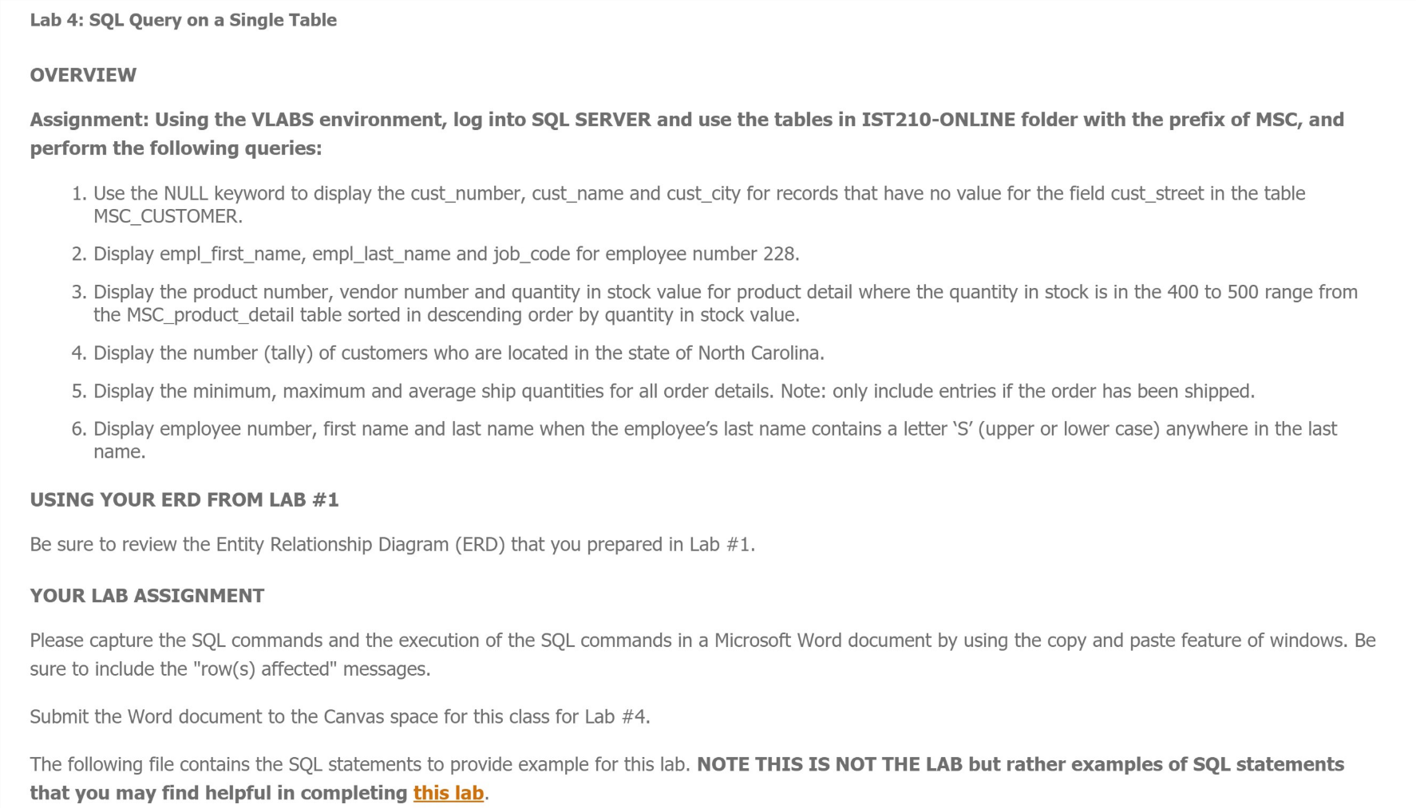Complete all [Lesson 05: Normalization of Database Tables](https://psu.instructure.com/courses/1958229/modules/3092484) online content, assignments, etc. by the due date.